**Visvesvaraya Technological University**

**Belagavi, Karnataka-590018**

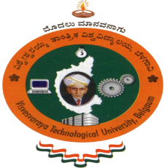

Report on

**“AICET Activity point Program”**

Submitted for partial fulfillment of the requirement for the award of the degree of

**Bachelor of Engineering**

**in**

**Electrical and Electronics Engineering**

**Submitted by**

**Madhu Gowda h k**- 4AD18EE015



**Department of Electrical and Electronics Engineering**

**ATME College of Engineering**

**13th K.M stone, Mysuru-Kanakapura- Bengaluru road, Mysuru-570028**

**2021-2022**

**ATME College of Engineering, Mysuru-570028**

|  |  |  |
| --- | --- | --- |
| Name | of Student | MADHU GOWDA H K |
| USN of Student | | 4AD18EE015 |
| Department | | Electrical and Electronics Engineering |
| Entry | to Program | Regular |
| Activity Points | | 50-Regular |
| Titles of Activity Under Taken | | * School teaching activity * Informing about feature Studies |
| Places of Activity | | * Huddukula * Bangarpet(T) |
| Dates | of Activity | 15-04-2022 to 29-04-2022 |
| Number Of Weeks or Hours involved | | 80 Hours |

**REPORT ON AICTE ACTIVITYPOINT**

Activity Point Earned

Department of Electrical and electronics engineering ,ATMECE Page 2

**TABLE OF CONTENT**

|  |  |  |
| --- | --- | --- |
| **Sl. Number** | **Title** | **Page Number** |
| **1** | **Classroom teaching activity**   1. Executive Summary or Abstract Introduction | 04 |
| **2** | Conduction of activity and photographs | 05-06 |
| **3** | Conclusion and outcome | 06 |
| **4** | Certificates | 07 |

Department of Electrical and electronics engineering ,ATMECE Page 3

**Helping local school to achieve good Results and enhance their enrolment in Higher education and briefing about technology**

**Objective:**

1. To help the children to select their field of study after 10th
2. Helping children to get to know about the present technology
3. Creating awareness of Entrepreneur and advantages of being one

**Description:**

We visited the Government High school Huddukula, Bangarpet (T) and met the students, and had a chance to interact with them. During our conversations with students, we find how they prepared for their 10th Board exams and what field of course they are willing join next and we got to know what they want to achieve in the future.

We helped them by briefing about the three major course that is Science, Commerce and Arts. And there were around 15 students with the 15 different ways of thinking. Even some of them already decided what course they are going join. We gave them the ideology of how the subjects will be and How important is KCET exam is and how to study parallelly.

Students were also educated with Entrepreneur and with the reference of **Vineeta Singh** and what makes a Entrepreneur different from others and with the help of Mr. Prakash Even we got to know about the Entrepreneur in their perspective

It was such a monotonous time for us being at college and being stressful with our work being indulged in the AICTE activity was the greatest stress buster for us. It was a much needed break where we invested our time qualitatively.

Faculties of government school, Huddukula, Bangarpet (T) Mr. Prakash sir and Miss Saroja mam helped us and appreciated the efforts of students of ATMECE for consistently helping and encouraging them in the wellness of the society

Department of Electrical and electronics engineering ,ATMECE Page 4

**Photograph:** 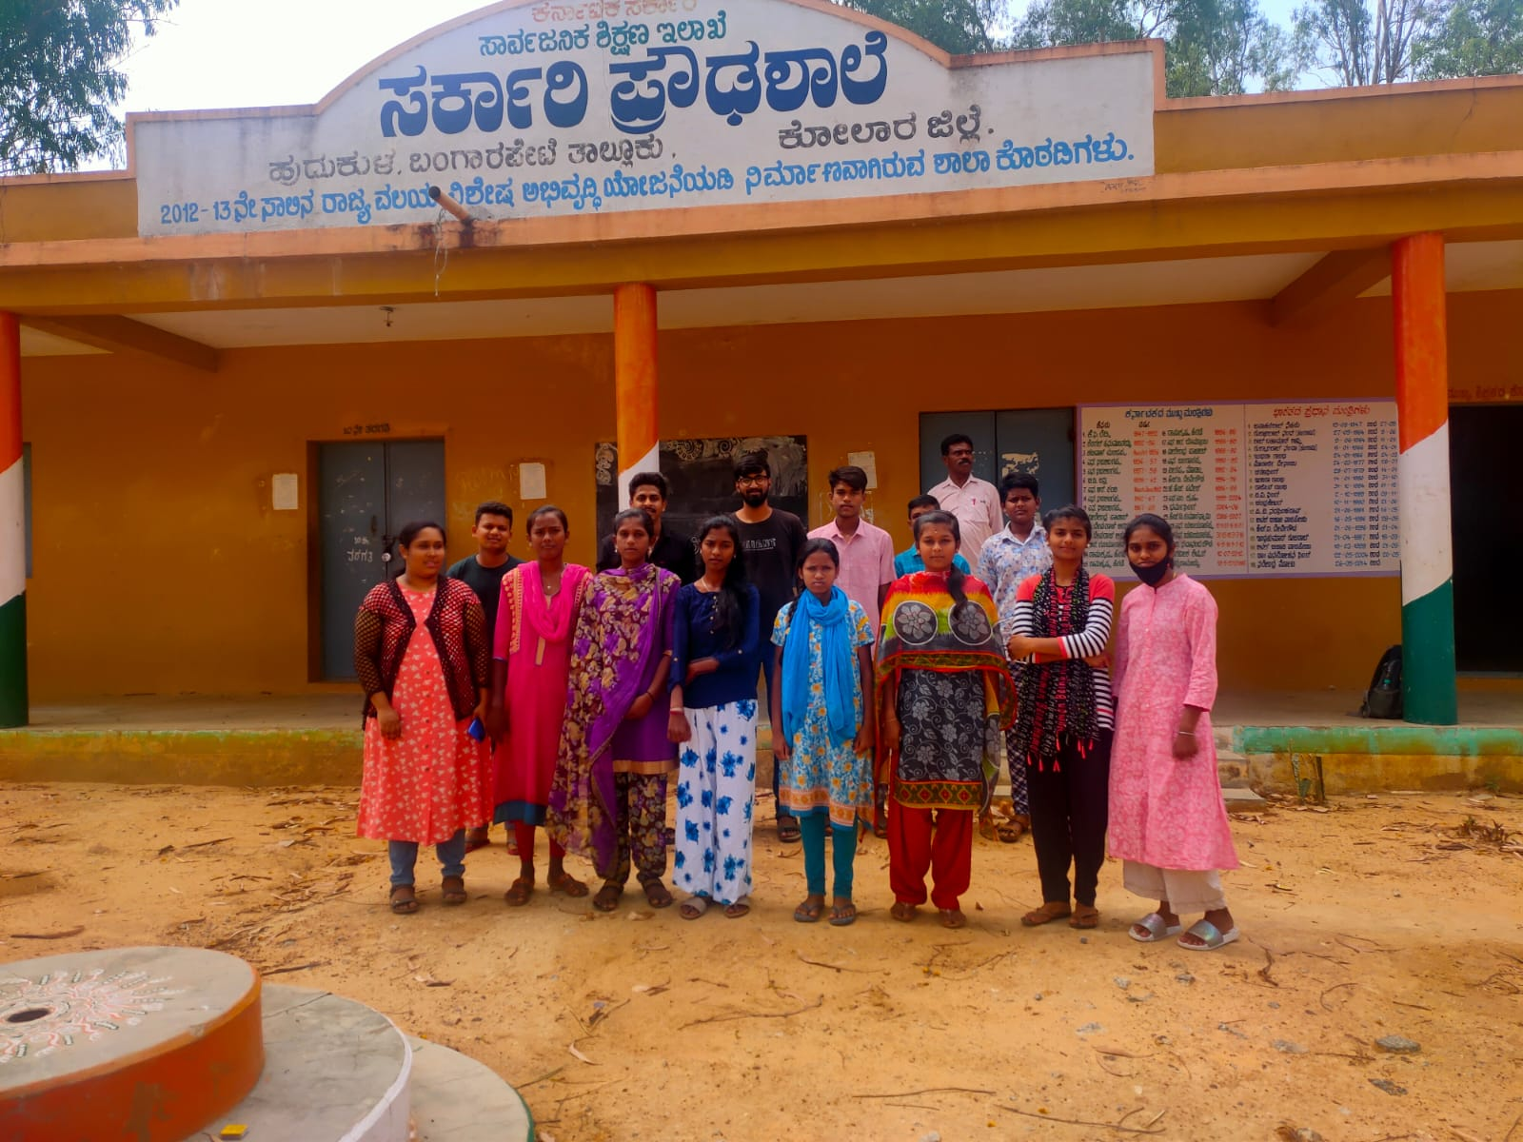

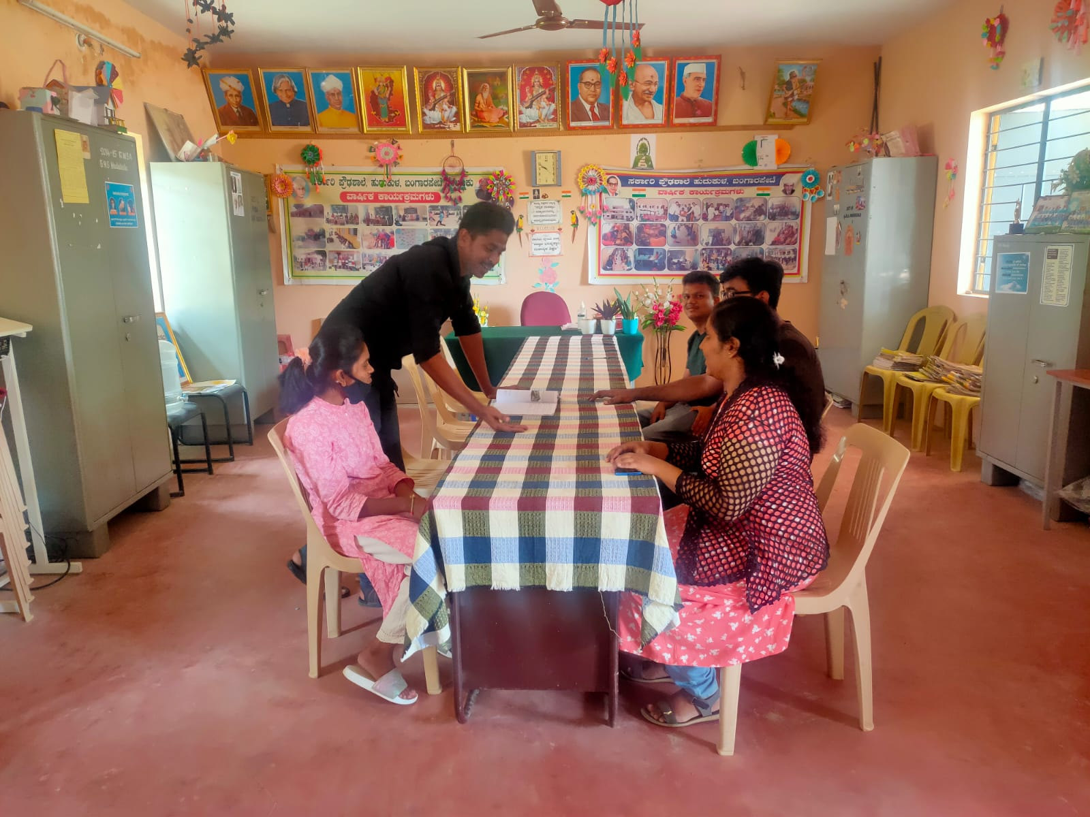

Department of Electrical and electronics engineering ,ATMECE Page 5

**My contribution :**

I got the chance to meet the Soo many different kind of Students and share the knowledge what I had. I had a conversation with students who are all wanted to be a software Engineer in the feature I got a chance to teach him about the Software Development and Software Testing and few basics of programming language.

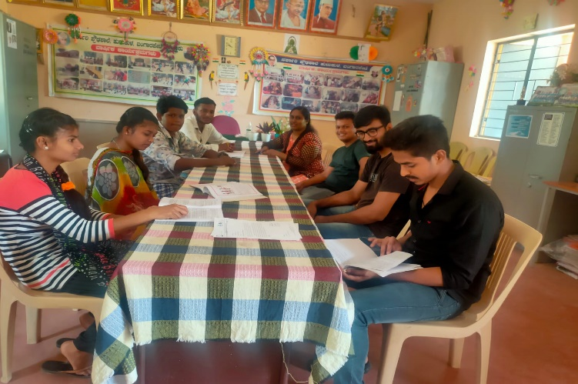

Also with that I got the chance to meet another young mind who wanted to be an Entrepreneur in the field of Designing with reference to Vineeta Singh I shared the knowledge what I had.

**Conclusion** :- on conducting this Activity we are able realise the importance of Education and how we can change the World with the power of knowledge.

Department of Electrical and electronics engineering , ATMECE Page 6

**Certificate :**

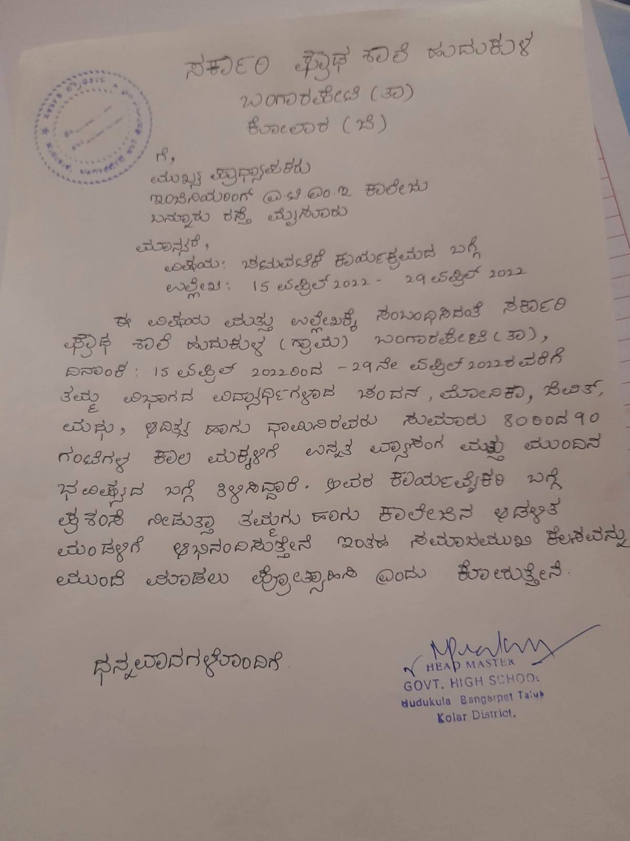

Details of the Teachers :-

Name :- Prakash R

Ph no :- 9901797921

Department of Electrical and electronics engineering ,ATMECE Page 7